[UNODC]
[The Exploitation and Trafficking of Children in Areas of Conflict]
[Farida Halim]
Forum: | United Nation of Drugs and Crime
Issue: | The Exploitation and Trafficking of Children in Areas of Conflict
Student Officer: | Farida Halim
Position: | Chair
Introduction
Throughout the past century, children's lives around the world have been marked by both massive believes and epic disasters. The employment of children as exploited workers in a variety of economic and social activities and the global affirmations of dedication to the rights of all children as a means of achieving their potential as productive people are two instances of this conflict that stand out above the rest. These differences about children's life are distressing, even during times of calm.
The forgetfulness of most of our modern senses and sensitivities is never complete, as if the abuse, neglect, and exploitation of children in peaceful settings were not already a striking enough picture; however, in places of war and conflict, this forgetfulness often seems to descend even further, and more is required to reach the depths of the horror and the fears. This is true for both small, localized conflicts and major and long-standing cruelty. In addition to being firmly committed to peace and to negotiations that offer a chance for social justice and safety, it is important—indeed, critical—to identify gaps in our knowledge for more specific factors and social boundaries that are relevant to particular issues.
We provide a case that highlights the exploitation and trafficking of minors in places of conflict. It forms part of a study on children in places of conflict or collaborative disturbances. These youngsters can be found in armed peace with low-intensity violence, civil conflict, international and non-international wars of all kinds and for all causes, and other scenarios. We present theoretical frameworks, underlying structural relationships, and the barriers created by particular features of the social contexts in which these kinds of situations evolve. The main processes that uphold or strengthen the severe dangers of child trafficking, exploitation, and control in these social contexts will next be discussed.

Definition of Key Terms
Exploitation
The action or fact of treating someone unfairly in order to benefit from their work.
Trafficking
The recruitment, transportation, transfer, harbouring or receipt of people through force, fraud or deception, with the aim of exploiting them for profit

General Overview
Children in conflict areas are used in a variety of ways:
- Child Soldiers: Forced recruitment of minors by armed groups is one of the most well-known types of exploitation in war zones. These kids, who are frequently as young as eight years old, are employed in combat as human shields, spies, or chefs. Children are frequently kidnapped, forced, or tricked into joining armed groups.
- Sexual exploitation: Increased sexual violence against minors is frequently the result of conflict contexts. Girls are particularly prone to forced marriages, human trafficking, and sexual assault. Armed organizations may utilize them as "wives" or as sex slaves.
- Forced Labor: Children in war areas are frequently forced into working in a variety of jobs, including household work, mining, and farming. These kids endure harsh labor conditions, significant physical abuse, and little to no recreation or educational opportunities.
- Trafficking: Children are trafficked for forced labor, unlawful adoptions, or sexual exploitation both inside and outside of conflict areas. Traffickers target kids because of their fragility and may sell them to traffickers or force them to move as refugees.
- Membership in Armies: Children may be enlisted against their will in local militias or rebel organizations. They frequently endure physical abuse, manipulation, and brutal brainwashing.
The consequences of exploitation and trafficking are devastating for children:
- Physical and Psychological Trauma: Children who are exploited in war areas frequently experience serious physical. and psychological injury, such as chronic illnesses brought on by forced labor, injuries from violence, and long-term mental health conditions including depression, anxiety, and PTSD.
- Loss of Childhood and Education: Children that are exploited in conflict areas frequently miss out on a typical childhood, education, and social growth. Children who are sent into the military or compelled to work might never go back to school or have the chance to live secure lives.
- Lifelong Damage and Stunted Development: Being trafficked or exploited in conflict areas can have long-lasting consequences that include social stigmatization, physical disability, and a lack of possibilities for economic progress.
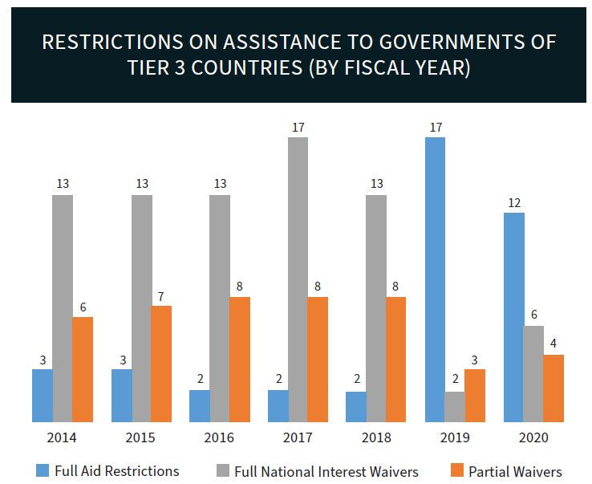

Major Parties Involved
Non-Governmental Organizations (NGOs) and Human Rights Groups (Responders)
During and after crises, a number of local and international NGOs, human rights organizations, and humanitarian groups strive to shield children from trafficking and exploitation. These groups are essential in helping children stranded in conflict areas by offering promotion, aid, and legal support.
Save the Children, UNICEF, and World Vision are some of the most famous organizations providing child safety services in war zones. They strive to provide displaced children with safe shelters, education, trauma treatment, and child protection initiatives.
Amnesty International and Human Rights Watch play a crucial role in identifying and recording child abuse, recruitment, and trafficking during conflicts. Their advocacy and reports aid in increasing awareness and holding offenders responsible.
Governmental Actors (State Responsibility or Negligence)
Although governments in conflict areas may not necessarily be actively involved in child trafficking or exploitation, they frequently contribute to it through ignorance, complicity, or a failure to safeguard children in areas affected by violence. State Armed Forces: Government security and military personnel may participate in child trafficking and exploitation. Governments occasionally ignore the abuse committed by armed groups or militias that support them. Additionally, state forces have been known to recruit minors, particularly in states with poor military discipline or during civil wars.
shady Government Officials: In some conflict zones, shady officials, especially border guards, police, or local leaders, may enable the trafficking of children in exchange for bribes or for political and military advantage. They may turn a blind eye to or even support child trafficking and exploitation to serve their interests.
The Role of the Global Community and Civil Society
Civil Society: Local communities and civil society organizations frequently contribute to awareness-building, educating kids about their rights, and offering impacted families unofficial support systems. In order to combat trafficking and exploitation at the local level, local activists and local groups are essential.

Timeline of Key Events
Date | Description of event
1924 | Geneva Declaration on Children's Rights  One of the earliest international attempts to create children's rights, this declaration was adopted by the League of Nations and laid the foundation for later child protection guidelines in conflict areas.
1949 | The Fourth Geneva Convention, which addresses the protection of civilians,  Children and other people were to be protected during armed conflict, according to this pact. It was an early attempt to protect children during times of conflict, even if it did not expressly address child trafficking or child soldiering.
2002  2021 | The International Criminal Court's (ICC) Rome Statute  An important step in bringing charges of those who exploit children in conflict was taken when the Rome Statute declared that the enlistment of minors in armed groups and their use in combat was a war crime.  The Taliban's Part in Abusing Afghan Children  Reports surfaced that the Taliban had expanded their recruiting of youngsters after seizing control of Afghanistan in August 2021, with many of them being used as human shields and in fighting positions. Reports of child trafficking for labor and sexual exploitation increased, making the situation for child protection worse.
UN involvement, Relevant Resolutions, Treaties and Events
- UN Security Council Resolution 1612 (2005): A framework for tracking and reporting on the effects of armed conflict on children, including the recruitment, use, and exploitation of child soldiers, was established by this resolution. The UN Security Council Working Group on Children and Armed Conflict (CAAC), which keeps an eye out for abuses of children's rights in conflict areas, was established as a result.
- UN Security Council Resolution 1612 (2005): This resolution supported the complete approach to child protection in conflict situations and underlined the requirement to monitor crimes against children.
- The Protocol to Prevent, Suppress and Punish Trafficking in Persons, Especially Women and Children (2000): The United Nations Convention against Transnational Organized Crime is supplemented by this international agreement. It deals with human trafficking, especially child trafficking, and seeks to stop such crimes, shield victims, and bring criminals to justice. In conflict areas, it is essential to the battle against human trafficking

- UN Special Representative for Children and Armed Conflict: In order to promote the protection of children in crisis areas, the office of the UN Special Representative for Children and Armed crisis is essential. The Special Representative strives to protect children from exploitation, including human trafficking, by increasing awareness, influencing policy, and encouraging the application of international laws. Leila Zerrougui (Algeria) and Olara Otunnu (Uganda) were notable previous Special Representatives.

Previous Attempts to Solve the Issue
The international community has long been concerned about the problem of child trafficking and exploitation in conflict zones. Numerous attempts have been made over the years to address this serious violation of children's rights, including international cooperation, advocacy campaigns, peacekeeping missions, humanitarian aid, and legal frameworks. Below are some notable previous attempts to overcome this issue:
- International Legal Instruments and Frameworks:
Optional Protocol to the CRC on the Involvement of Children in Armed Conflict (2000)- Established in 2000, this agreement focuses on the use and recruitment of minors in armed conflicts. It requires that states take all necessary steps to stop the recruitment of minors and establishes 18 as the minimum age to participate in hostilities. Additionally, it requires that kids connected to the military or armed groups be reformed. Although there are still issues, especially when non-state armed groups take advantage of children, this policy was a major breakthrough in the fight against child exploitation in conflict.

The UN Convention against Transnational Organized Crime and the Trafficking Protocol (Palermo Protocol) (2000) - The Protocol to Prevent, Suppress, and Punish Trafficking in Persons, particularly Women and Children, is part of this agreement, which was approved by the UN General Assembly in 2000. It requires states to take action to stop trafficking, protect victims, and bring traffickers to justice. It also creates a framework for international collaboration in the fight against trafficking. Addressing child trafficking in conflict areas, where armed organizations frequently take advantage of defenseless children, requires adherence to this procedure.

- International Partnerships and Multi-Stakeholder Initiatives:
The UN Action Against Sexual Violence in Conflict – 2007- In order to combat sexual violence in conflict—a type of exploitation that frequently involves forced prostitution and trafficking—13 UN agencies are collaborating on this project. In addition to providing services for survivors, including children who are frequently the victims of human trafficking and sexual exploitation, the initiative seeks to improve responses to sexual violence and encourage accountability.

The Inter-Agency Working Group on Child Protection in Crisis (CPWG)- UNICEF, Save the Children, and other international NGOs are part of this group, which aims to provide rules, standards, and resources for safeguarding children in emergency situations, including conflict areas. In addition to offering technical help to humanitarian organizations operating in conflict-affected areas, the CPWG has created policies and procedures to combat child soldiering, human trafficking, and other types of exploitation.

- Regional Efforts:
The African Charter on the Rights and Welfare of the Child (1990)- One of the most important pieces of legislation in Africa's fight to shield children from exploitation during times of conflict is the African Charter on the Rights and Welfare of the Child. The Charter offers a regional framework for holding governments responsible for infractions and expressly targets the recruitment of children into armed conflict. The Charter has served as the foundation for national child protection policy in a number of African nations.

Possible Solutions
Comprehensive and coordinated solutions that address the immediate needs of war-affected children as well as the structural causes that increase their susceptibility are needed to address the problem of child trafficking and exploitation in conflict regions. The following list of potential remedies emphasizes accountability, protection, prevention, and rehabilitation:
- Strengthening Legal and Policy Frameworks:
Regional and International Cooperation- Regional Child Protection Cooperation: To develop a coordinated response to child exploitation, nations should collaborate through regional frameworks (such the African Charter on the Rights and Welfare of the Child). These frameworks need to make it easier to exchange information, cooperate together to combat human trafficking, and create secure migration and safety pathways.
- Prevention of Recruitment and Exploitation:
Addressing Root Causes of Child Recruitment- Financial Assistance for Families: One of the main causes of child exploitation is poverty. Offering financial support, such as cash transfers, microlending, and community development initiatives, can lessen children's susceptibility to being recruited by trafficking organizations or armed groups. Enhancing educational programs and career training can also provide kids other options.

Community Education and Awareness: It's critical to educate communities affected by conflict on the dangers of child trafficking and exploitation. Children, parents, and communities should all be made aware of the risks posed by trafficking networks, armed organizations, and forced labor through education initiatives.

Main link used: https://www.un.org/en/mun

