Forum: | Human Right Council
Issue: | The Ever-Growing Oppression of the Uyghur Muslim Population in China
Student Officer: | Layla Hatem
Position: | Deputy President
Introduction
. The oppression of the Uyghur Muslim population in China, in the region of Xinjiang has become a crucial human rights concern over the past two decades, this issue is situated within a politically charged environment characterized by state-driven narratives of national security, often used to justify widespread surveillance and cultural erasure. Beyond detentions, Uyghurs in the region have been subjected to intense surveillance, forced labor, and involuntary sterilizations, among other rights abuses. This crisis reflects a complex intersection of religious discrimination, state control and global silence fueled by economic interests.
The USA and several other foreign governments have described this system as genocide, as the scale is underscored by alarming statistics, reports estimate that over one Million Uyghurs and other Muslim minorities have been detained in what the Chinese government refers to as “re-education camps”. Human Rights organizations have documented surveillance measures, such as biometric data collection and AI monitoring systems, which have created a climate of fear and isolation.
Furthermore, the legal consequences attached to such conduct are unpredictable and insufficiently regulated. Authorities are granted broad investigative, preventive and coercive powers with limited safeguards and independent judicial oversight. Individually and cumulatively, these factors present significant concerns as to the system’s compliance with international human rights law, establishing a framework that is vulnerable to arbitrary and discriminatory application.
Addressing the plight of the Uyghur population is not just a master of human rights but also a test of international accountability and moral leadership, it is imperative to consider the broader implications of this issue and work towards effective solutions that prioritize justice and dignity for all.

Definition of Key Terms
Uyghurs
There are about 12 million of the Uygur, a minor population in China, mostly Muslim, living in Xinjiang, which is officially known as the Xinjiang Uyghur Autonomous Region (XUAR). The Uyghurs speak their own language, which is similar to Turkish, and see themselves as culturally and ethnically close to Central Asian nations. They make up less than half of the Xinjiang population. The Uyghurs are recognized as the titular nationality of the XUAR. They are one of China’s 55 officially recognized ethnic minorities.

Extremism
Extremism is the promotion or advancement of an ideology based on violence, hatred or intolerance, that aims to negate or destroy the fundamental rights and freedoms of others and it is seen as a high bar that only captures the most concerning of activities. Extremists typically hold rigid and uncompromising views, seeking radical changes that may challenge or destabilize the existing system. While not all forms of extremism are violent, the often contribute to societal harm.

Reeducation camps
Facilities where individuals are detained and subjected to indoctrination programs under the guise of education or rehabilitation, these camps are often associated with authoritarian regimes and designed to force detainees to conform specific political, ideological or cultural norms.
The CCP
The Chinese Communist Party, is a ruling party of the People’s Republic of China(PRC) and the central authority that governs the country. It was founded in 1921 and it has evolved over time into a highly centralized political organization with a goal of national development and maintaining state.

General Overview
The Oppression of the Uyghur Muslim population in China
The Uyghurs are a Turkic ethnic group with a distinct cultural, religious, and linguistic identity. Looking at the historical background, they have inhabited the Xinjiang region, which is an area known for its important trade and their natural resources. Year after year, tensions between Uyghurs and the Chinese government have been increasing and fueled by cultural differences, political marginalization, and economic disparities.at the end of the 20th century, growing calls for greater autonomy in Xinjiang were met with increasing state control, laying the foundation for the current conflict as the government framed the actions as extremism and separatism.
Starting officially in the early 2000s, there was the war known as “The War on Terror”, the global War on Terror after 9/11 provided China with a narrative to justify increased surveillance and control over minor populations, especially Uyghurs. Labeling the Uyghur activity as a "terrorist threat," China started to introduce measures aimed at suppressing dissent and preempting unrest. Then in the years 2014 to 2016,there was the The Strike Hard Campaign under President Xi Jinping, policies in Xinjiang shifted dramatically. The 2014 “Strike Hard Campaign Against Violent Terrorism” started the beginning of large-scale state repression. Authorities implemented advanced surveillance technologies, including facial recognition cameras, biometric data collection, and AI monitors for Uyghur individuals extensively. And until recent years, by 2017, credible reports emerged of mass detentions in the “vocational training centers” or “re-education camps.” These facilities detained over one million Uyghurs and other Muslim minorities in the state. Inside these camps, detainees were subjected to forced indoctrination, renunciation of religious practices, forced labor, and psychological abuse. Many survivors have recounted severe human rights violations, including physical torture, sexual abuse, and forced sterilizations.
The oppression of the Uyghur population extends beyond human rights abuses within Xinjiang,China , impacting global economies, geopolitics, and ethical governance. Xinjiang is a huge global supplier of cotton and solar energy components. Reports linking forced labor to these industries have raised ethical concerns about global supply chains. Companies and governments worldwide face pressure to scrutinize their trade relationships with China, potentially disrupting global markets. The state’s policies have targeted Uyghur cultural heritage, including the destruction of mosques, restrictions on traditional practices, and bans on religious attire. These actions aim to assimilate Uyghurs into mainstream Han Chinese culture, effectively erasing their distinct identity.
The crisis has resulted in widespread psychological trauma, family separations, and generational loss for Uyghur communities. Human rights organizations warn that the continued silence or inaction from the international community could embolden similar practices elsewhere, undermining global commitments to human rights.
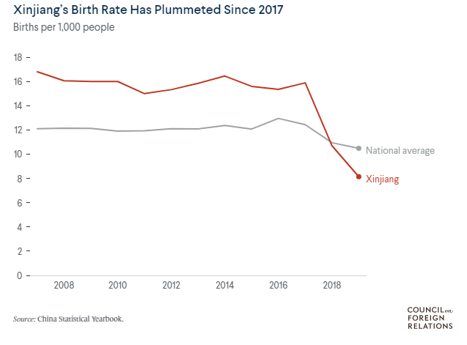
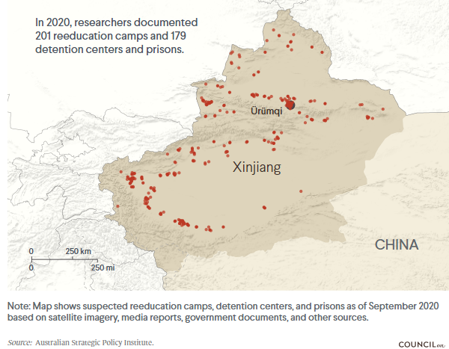
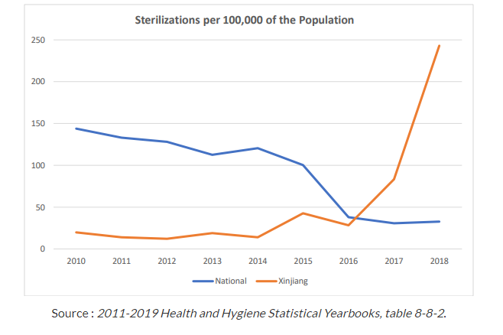

Major Parties Involved
The Chinese Government (CCP)
The Chinese communist party is the central actor of the issue, it has implemented and justified policies in Xinjiang under the pretext of countering terrorism, separatism and extremism. Its role includes mass detentions, surveillance and control,forced assimilation and economic exploitation.

United Nations Human Rights Council (UNHRC)
This non-governmental organization has played a crucial role in documenting and exposing the situation in China, advocating for global action to hold the state accountable and pressures governments and corporations to address human rights violations.
Turkey
As a majority-Muslim nation with cultural and historical ties to Uyghurs, Turkey has voiced concern over their treatment. However, its economic relations and ties with China complicate its position.
European Union
The EU, an organization consisting of most countries in Europe, has similarly sanctioned individuals and entities linked to Xinjiang abuses and has increased scrutiny of its trade with China.
Russia
Russia is a close ally of China and it avoids criticizing its domestic policies and often aligns with China on international platforms. Russia is a part of counterterrorism and anti-extremism efforts; it defends China’s right to manage its internal affairs without external intervention.

Organization of Islamic Nations (OIC)
Many Muslim-majority nations and the members of the OIC, which represents 57 Muslim nations, have faced criticism for their muted response to the crisis, often attributed to economic and strategic considerations rather than religious solidarity.

The United States of America (USA)
The USA has been a leading voice in condemning China’s oppression of the Uyghur Muslim population, and has labeled it as a genocide and a crime against humanity, it has also imposed several sanctions on Chinese officials like the Uyghur Forced Labor Prevention Act and advocated for international action through the UN and G7. While the USA supported advocacy groups and granted asylums to fleeing people, the approach is also tied to broader geopolitical rivalry with China.

Timeline of Key Events
Date | Description of event
October 1, 1949 | Xinjiang is incorporated into the People’s Republic of China as the XUAR.
February 5, 1997 | The Ghulja incident occurs, protests by the Uyghurs are violently suppressed, resulting in deaths and arrests.
December 15, 2001  July 5, 2009  April 1, 2017  September 10,2018  July 12, 2019  July 13, 2019  September 14, 2020  August 31, 2022  December 23,2022 | The UN designates the East Turkestan Islamic Movement ETIM, a Uyghur separatist group,as a terrorist organization, China begins framing the Uyghur activism.  Ethnic riots erupt in Urumqi, leading to nearly 200 deaths, China responds with massive arrests and increased surveillance in Xinjiang.  Reports of large-scale detentions in “re-education camps”, Uyghurs are detained for practicing religion and traveling abroad.  The UHRC reports that over 1 million Uyghurs are being held in detention camps.  22 countries including the USA, Canada and Japan, signed a joint letter to the UN condemning China’s actions.  37 countries including Saudi Arabia and Russia, signed a counter-letter supporting China’s policies.  Reports emerge of Uyghur forced labor being used in global supply chains.  The OHCHR releases a report detailing potential crimes against humanity in Xinjiang.  The USA passes the Uyghur Forced Labor Prevention Act, banning imports of goods linked to Xinjiang’s forced labor practices.

UN involvement, Relevant Resolutions, Treaties and Events
- United Nations Office of the High Commissioner for Human Rights (OHCHR). Assessment of Human Rights Concerns in Xinjiang Uyghur Autonomous Region, China, 31 August 2022 (A/HRC/50/23).
- United Nations General Assembly. Third Committee, Joint Statement on Behalf of 50 Countries Expressing Concern Over Human Rights Situation in Xinjiang, China, 31 October 2022 (A/C.3/77/L.37).
- United Nations Human Rights Council (UNHRC). Report on Human Rights Violations in Xinjiang, 10 September 2018 (A/HRC/39/32).
- United Nations Human Rights Council (UNHRC). Resolution on Xinjiang Human Rights Situation, Rejecting the Call for a Debate, 6 October 2022 (A/HRC/51/L.1).
- United Nations General Assembly. Joint Declaration on the Human Rights Situation in Xinjiang, China, 23 December 2022 (A/RES/77/24).

Previous Attempts to Solve the Issue
The international community has made several attempts to address the Uyghur crisis in Xinjiang, primarily through advocacy, sanctions, and diplomatic efforts. One of the earliest collective actions was the United Nations’ engagement, including reports by the Office of the High Commissioner for Human Rights (OHCHR). These reports outlined human rights abuses in Xinjiang and encouraged the global community to hold China accountable. However, despite efforts to initiate debates in the UN Human Rights Council, such motions were often blocked by coalitions of countries allied with China, highlighting the political divisions that hinder effective action.
Economic sanctions have been another key strategy. The United States and its allies have imposed targeted sanctions on Chinese officials and entities implicated in the abuses, including bans on imports of products linked to forced labor in Xinjiang. The Uyghur Forced Labor Prevention Act, enacted by the U.S. in December 2021, is one of the most significant measures to restrict goods tied to Xinjiang's supply chains. Similarly, the European Union has issued sanctions under its human rights mechanism, although these efforts are limited by competing economic interests with China.
Advocacy by human rights organizations and Uyghur diaspora groups has brought global attention to the issue. NGOs like Amnesty International and Human Rights Watch have published comprehensive reports and pushed for greater international action. Despite these efforts, the response has been inconsistent, with many Muslim-majority nations refraining from condemnation due to economic and political dependencies on China. These previous attempts, while raising awareness, have not led to significant changes on the ground, leaving the crisis unresolved

Possible Solutions
One way to address the Uyghur crisis is by conducting independent investigations into the situation in Xinjiang. The United Nations or other international organizations could send experts to the region to gather facts and report on what is happening. If abuses are confirmed, it could lead to legal action, with the possibility of holding Chinese officials accountable for crimes. This would ensure that human rights violations are fully understood and those responsible face consequences. A possible solution is creating a special UN tribunal or using the International Criminal Court (ICC) to investigate and prosecute those responsible.
Another proposal is for countries around the world to impose stronger sanctions on China. For example, governments could stop importing goods made with forced labor, especially from regions like Xinjiang. This would hurt China's economy and show that the international community will not support businesses involved in human rights abuses. Countries could also freeze assets or ban travel for Chinese officials involved in the repression of Uyghurs. These actions could encourage China to change its policies toward Uyghur Muslims and respect their rights.
Supporting the Uyghur community globally could help raise awareness and put pressure on China. This could include offering safe havens for Uyghur refugees who have fled the country, giving them the chance to live freely and safely. International organizations and governments could also increase support for advocacy groups that work to expose the situation in Xinjiang. Encouraging media outlets to cover the issue and giving a platform to Uyghur voices would help ensure the crisis stays in the spotlight and motivate governments to take stronger action.

Bibliography

Amnesty International "China: New Report Confirms Systematic Oppression of Uyghurs." Amnesty International, 2020, www.amnesty.org/en/latest/news/2020/07/china-new-report-confirms-systematic-oppression-of-uyghurs/.

Human Rights Watch. "China’s Mass Detention of Uyghurs and Other Turkic Muslims." Human Rights Watch, 2018, www.hrw.org/report/2018/09/13/under-xinjiang-china-has-imprisoned-more-than-1-million-muslims.

United Nations Office of the High Commissioner for Human Rights (OHCHR). "Assessment of Human Rights Concerns in Xinjiang Uyghur Autonomous Region, China." OHCHR, 31 Aug. 2022, www.ohchr.org/en/documents/country-reports/ohchr-assessment-human-rights-concerns-xinjiang-uyghur-autonomous-region.

New York Times. "‘Absolutely No Mercy’: Leaked Files Expose How China Organized Mass Detentions of Muslims." The New York Times, 16 Nov. 2019, www.nytimes.com/2019/11/16/world/asia/china-xinjiang-detentions-leaks.html.

BBC News. "China’s Crackdown on Uyghur Muslims: What’s Happening?" BBC News, 2021, www.bbc.com/news/world-asia-china-54201987.

United States Department of State. "2019 Country Reports on Human Rights Practices: China (Includes Tibet, Hong Kong, and Xinjiang)." U.S. Department of State, 2019, www.state.gov/reports/2019-country-reports-on-human-rights-practices/china/.

Xinjiang Victims Database. "Profiles of Uyghur Victims of Chinese Repression." Shahit Biz, www.shahit.biz.

Council on Foreign Relations (CFR). "The Xinjiang Crisis and Global Reactions." Council on Foreign Relations, 2020, www.cfr.org/global-conflict-tracker/conflict/xinjiang-crisis.

Uyghur Human Rights Project (UHRP). "Uyghur Human Rights Project Reports." Uyghur Human Rights Project, 2020, www.uhrp.org.

The Guardian. "The Forced Sterilization of Uyghur Women in Xinjiang." The Guardian, 10 Dec. 2020, www.theguardian.com/world/2020/dec/10/the-forced-sterilization-of-uyghur-women-in-xinjiang.

Appendices
Appendix I
UNHCR: https://www.ohchr.org

Appendix II
Council on foreign relations: https://www.cfr.org/

Appendix III
BBC: UNHCR: https://www.bbc.com

