Research Report

On

The Israeli -Palestinian Conflict

By Salma Aboushady
Rr
Forum | Security Council
Issue: | Resolving the Israeli-Palestinian conflict
Student Officer: | Salma Aboushady
Position: | Deputy President

Introduction
The Israeli-Palestinian Conflict is one the world’s greatest longest conflicts in modern history. The conflict began in the mid-20th Century. It involves the partitioning of land the official territory of Israeli and Palestinian nations. Since the beginning of the conflict, there have been periods of high tensions with many casualties from both sides. Both sides believe in the spread of their nationality and ideology, ensuring that they are the majority within a population. This has led to violent battles, riots and uprisings. Except for Israel and Palestine themselves, there has also been a global involvement from nations around the world. Through resolutions and agreements, the United Nations has attempted to solve the issue however peace has yet to be restored.

Definition of Key Terms

Arabs
Those with Arabic as their native language. In modern usage, this term refers to people living across the globe; from the Atlantic coast of Africa to Iran, Egypt, Syria, Iraq and many more.
Regarding Palestine, 86% of the population is Arab.

HAMAS
A militant movement and one the two main palestinian political parties. The name is an acronym of an Arabic phrase which translates to “Islamic Resistance Movement”. The HAMAS formed in 1987 during the first Palestinian Intifada. Its aim is to establish an Islamic Palestinian state instead of an Israelian one. When doing so, they reject any agreements made between the PLO and Israel. It mainly acts in the Gaza Strip and in areas within the West Bank. The HAMAS’s military wing has attacked numerous Israelian but also Palestinian territories since the 1990s. It has ranged from small attacks to greater ones where rockets and bombs have been used.

Intifada
A rebellion, uprising or resistance movements. Intifada means “tremor” or “shivering” in Arabic. It is used to describe the action of standing up and fighting against oppressors. The first Palestinian intifada began in 1987 and lasted until 1993 whilst the second one was in 2000.

Mandate
The authority granted by an electorate, such as the League of Nations, to act as a territory’s representative. In 1922, the League of Nations gave a mandate of the Palestinian territory to the United Kingdom.

Massacre
A brutal killing of a large number of people. Specifically, the victims are usually referred to as people that do not take part in the fighting or have no means and equipment to defend themselves.

Ottoman Empire
The Ottoman Empire, also known as the Turkish Empire, was an Empire that controlled a significant part of Southeast Europe, Western Asia and Northern Africa. This took place between the
14th and 20th century. They ended the Byzantine Empire with the conquest in Constantinople in
1453. After World War 1, where they suffered defeat, the empire was abolished on the 1st of November 1922 by treaty.

Settlers
People that move, often illegally, in a large group in order to live in a new area or country.
Within the Israeli-Palestinian conflict, the main settlements are the Israeli settlements. They involve Jewish civilians that have settled in areas that Israel occupied during the 6 Day War. According to international law, these disputes are illegal however Israel does not recognise it so. The main Israeli settlements are currently in the West Wank and in the Golan Heights.

Zionism
An extremist national movement for the protection of the Jewish nation. It was first established as a political party in 1897. Jews as well as numerous non-jews consider themselves Zionists as they are supporters of the Jewish state. (“Zionism”)

General Overview

Origin of the conflict
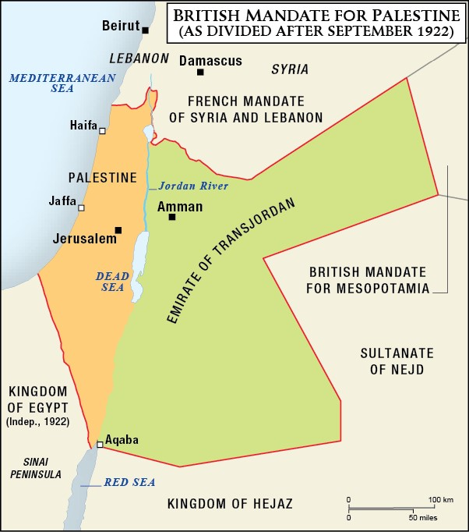
After the Ottoman Empire had been defeated in World War One (WW1), Britain took control of the area, now known as Palestine. The population of this land consisted of an Arab majority and a Jewish minority. (BBC News) In 1922, the League of Nations granted a mandate of the Palestinian Territory to the UK. At that time, the British were allowing jewish immigration and the number of jews increased significantly however by the 1930s, they began to resist this. During Britain's control, the international community instructed them to create a “national home” for the Jews. Though the Jews were ancestors of the area, Palestinians also believed that this land was their homeland. This caused tensions to grow between the two groups.
Figure 1: British Mandate

In 1947, the United Nations (UN) voted for Palestine to be split into two; one state for the Jews and one state for the Arabs. The aim was for Jerusalem to then become an international city, meaning that it would become an international zone. This plan was accepted and further implemented by the Jews however the Arabs strongly resisted. In the next year, 1948, Great Britain terminated the Mandate they previously had. The British rulers left the territory and Israel declared the independence of their nation. Once again, Palestinians were against this movement and war officially began. Soon, a massacre took place in an Arab village in April 1948. As an immediate retaliation, Arab forces attacked a Jewish convoy. (The Editors Of Encyclopaedia Britannica) Military troops from neighbouring Arab countries quickly became involved in the conflict and invaded the territory. On the 15th of May 1948, The Arab-Israeli war took place due to Syria’s declaration of independence. Egypt, Transjordan, Syria and other forces from Iraq entered Palestine, occupying different areas of South and East Palestine as well as East Jerusalem. They easily took control of the Arabs and attacked the Israeli forces. This war lasted 10 months and the result of it was that the State of Israel controlled the territory for the Jewish state that the United Nations (UN) had proposed as well as 60% of the area that was assigned to the Arab State. After the war, Egypt controlled Gaza whilst Jordan controlled the West Bank. This time period is referred to as the War of Independence for Israel whilst the Arabs know it as the Nakba (“catastrophe”). This name originates from the great number of refugees that emerged due to the war.
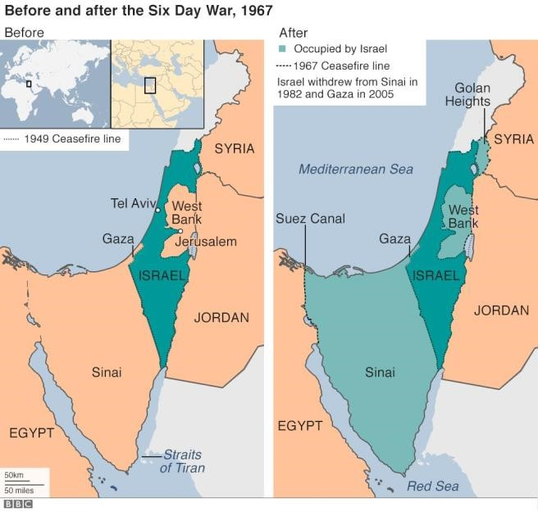
The following year, the fighting ended with Israel controlling most of the land. A division of Jerusalem took place, between the Israeli forces in the West and Jordanian ones in the East. Though this arrangement took place, there was no official peace agreement, hence the conflict was still not resolved. This led to multiple rising tensions and wars in the past decades. In 1956 the Suez Crisis took place between the 29th of October and the 7th of November. Earlier in the year, the Egyptian president Nasser had nationalised the Suez Canal Company. This conflict was Britain’s, France’s and Israel’s response to the nationalising. They invaded the canal zone in the aim of protecting their interests. In 1967, the 6 Day war, where Israel successfully occupied East Jerusalem, Gaza, Golan Heights and Sinai Peninsula, took place. Israel was occupying all the Palestinian territories, hence they were also governing the opposition. The Israeli government established military rule and control on Palestinians. Unlike the Israelians, the Palestinains’ basic needs were not met. The Israeli frequently engaged in inhumane actions such as killing and torturing.
Figure 2: Before and after the Six Day War
The Yom Kippur War, also referred to as the
Ramadan War, was in 1973. It was a conflict fought between Israel and a coalition of Arab states led by Egypt. It mainly happened in the Sinai Peninsula on the Golan heights. The Golan heights were, at the time, occupied areas by Israel. Egypt’s aim was to seize the east area of the Suez Canal. Israel won this conflict, by pushing the Egyptians out of Sinai and retaking the Golan heights from Syria. The first main step to achieving peace was the Camp David Accords in 1978. This was the beginning of peace between Arab states and Israel. This however did not mean that Palestein was also satisfied. From here on, the conflict became an Israeli-Palestinian one. Over the next years, the Jewish settlements increased significantly. Israeli settlers attempted to live on Palestinian land, making it more difficult for Palestine to become an independent state.
The Lebanon War started in 1982, when Israel invaded in order to attack the Palestine Liberation Organisation (PLO). (The Editors of Encyclopedia Britannica) Israel invaded South Lebanon in the middle of the Lebanese Civil War. The invasion was designed to weaken the PLO, politically as well as economically. Eventually, though there was great destruction, the PLO was driven out of
Lebanon. Additionally, they aimed to make the Lebanese Civil War favor Israel’s right-wing allies. In 1987, the first Intifada was launched by unarmed Palestinians. (Vox) They did not use firearms or explosives however wanted to act as a retaliation to the excessive control and suppression of nationalism which they were receiving. Israel’s response was once again backed up with heavy force.
The first step for Israel withdrawing from the Palestinian territory were the Oslo Accords in
1993. The Oslo Accords, officially known as the Declaration of Principles on Self-Government Arrangements, were signed by Israel and the PLO in Washington DC, after the United States’ involvement. The aim was to create a new approach for achieving a peaceful resolution in regards to the Palestinian-Israeli conflict by engaging in communication between Israel and the PLO. Eventually, no permanent agreement was made, however there were progressions. The Creation of the Palestinian National Authority aided the self-governance of Palestine. The PLO was legitimised internationally for the first time and Israeli forces were removed from Gaza, Jericho as well as from areas in the West Bank. Nevertheless, the Oslo Accords were not as effective as anticipated. There continued to be a lack of negotiation between two oppositions. This agreement officially ended with the failure of the Camp David Summit in 2000. Subsequently, the second Intifada took place. This Intifadas was another Palestinian uprising, however significantly more violent than the first. As a result, Israel built checkpoints and walls to completely protect and isolate themselves from the Palestinians. Furthermore, Israel withdrew from Gaza and the Hammas gained power though they split from the Palestinian authority.
The latest major battle, regarding the Palestinian - Israeli conflict, was the Battle of Gaza in
2007 where The Hamas took over th e
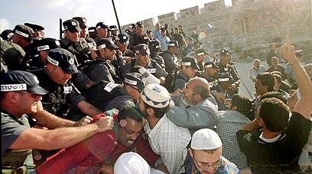
Gaza strip. This battle was between
Hamas and Fatah, formerly the
Palestinian National Liberation Movement. Fatah had recently lost the parliamentary elections in 2006 and hence the conflict involved the struggle of gaining power. Hamas were removed from the Gaza stirp and the West Bank Figure 3: Battle of Gaza was split into two.

The conflict in 2023
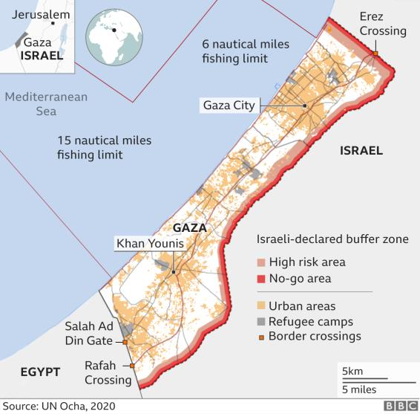
Though the main battle concerning this Israeli-Palestinian conflict took place in 2007 the tensions continue to rise and the path to peace seems to constantly be further. 2022 was the deadliest year for the Palestinains within the past 16 years with more than 200 Palestinian killings. The conflict has also escalated in 2023. On the 27th of January, 9 Palestinians were killed during a military attack in jenin and on the 23rd of February Palestinian and Israeli military fought with rocket fire in the Gaza strip. Israel’s political state changed in 2022 when a new right wing-government was formed with the Prime Minister continuing to be Benjamin Netanyahu. The new coalition formed was based on Zionism. They have controversial and strong opinions and are more brutal towards the Palestinians. The new government’s ideology is expected to only fuel the conflict further. (Story)
On the 26th of February 2023, Israeli and Palestinian delegates made a joint commitment in the
aim of decreasing the violence. Any possible positive effects from these decisions have not become apparent within the last few months. The chair of the Zionist party rejected the settlement freeze and the Prime Minister of Israel tweeted that no pause would take place. According to Israeli authorities, the increase violence in the past year was due to them sending military troops in order to deescalate the situation. On the other hand, Palestine holds Israel responsible for the violence and believes that the Israeli settlers are terrorists. The number of raids are only increasing and there are great suspicions that a new Intifada is likely to take place in the near future.

Major Parties Involved

Palestine
Palestine lies within the eastern mediterranean region. It comprises parts of modern Israel, some Palestinian territories of the Gaza Strip and the West Bank. Palestine is currently recognised by 138 out of the 193 United Nations (UN) member states and it is officially governed by the Palestine Liberation Organisation (PLO). This government has not held elections for 16 years. The main political parties of Palestine include the Islamic Resistance Movement (Hamas), the Palestinian National Liberation Movement (Fatah) and the Popular Front for the Liberation of Palestine (PFLP).

Israel
Israel, officially State of Israel, is located in the Middle East, at the eastern part of the Mediterranean Sea. It borders Lebanon, Syria, Jordan and Egypt. The country recognises Jerusalem as the capital of Israel, however this claim has not received international recognition. It is currently the only Jewish nation. The Israeli Government is based on parliamentary democracy. Since 2022, Benjamin Natanyahu has been the prime minister of Israel. The main political parties of the country include National Unity and Religious Zionism. In general, politics in Israel is greatly dominated by Zionist parties.

Hamas
Hamas is a Palestinian military group that, over the years, has unsuccessfully attempted to govern Gaza. Nevertheless, it currently governs more than two million Palestinians in that territory. The party is also known for its political resistance to Israel. Though Palestinian, this party rivals with the Fatah which dominated the Palestine Liberation Organisation. (“National Counterterrorism Center | Groups”)

United Kingdom (UK)
Britain has been involved in the conflict from the very beginning, when becoming responsible for Palestine under the League of Nations mandate. In 1948 however, they left the Palestinian territory and left the Jews and Arabs to fight. Currently, the United Kingdom is one of the countries in the United Nations that does not recognise Palestine as an independent state. On the 6th of January 2023, the United Kingdom announced that they oppose any violent actions which will make achieving peace more difficult. Nevertheless, in the past, the UK and Israel have had a strong defence relationship. They have attained this through dialogue and agreement for military cooperation.

United States of America (USA)
The United States of America has expressed their strong support of Israel since the 1960s. It
has helped the country build relations with neighbouring Arab countries including Jordan, Lebanon and Egypt. The US has also aided Israel economically. To this date, the United States has provided Israel with approximately 158 billion dollars. Various treaties and agreements strengthen the economic relations. Nevertheless, various US presidents in the past have proclaimed the necessity for Israel to give up a section of land which they had conquered from Palestine in 1967 in order to achieve peace.

Timeline of Key Events
Date | Description of event
July 22nd 1922 | The League of Nations gives a mandate of the Palestinian territory to the United Kingdom.
November 29th 1947 | The United Nations vote for Palestine to be split into two; one state for the Jews and one for the Arab. This is called the UN Partition Plan.
November 30th, 1947 | The Israeli War of Independence begins.
May 14th, 1948 | Great Britain terminate the Mandate.

May 11th, 1949 | Israel becomes a UN member.
October 29th , 1956 | The Suez crisis begins.
June 2nd, 1964 | The Palestinian Liberation Organisation (PLO) is founded in Cairo.
June 5th 1967 | The 6-day war takes place.
October 6th, 1973 | The Yom Kippur War begins.
November 22nd, 1974 | The UN General Assembly recognises the PLO as the only legitimate representative of Palestine and its citizens.
September 17th, 1978 | The Camp David Accords political agreements were signed.
December 8th, 1987 | The first Intifada takes place.
September 13th, 1993 | The Oslo Accords were signed.
September 28th, 2000 | The 2nd Intifada, a Palestinian uprising, takes place.
June 10th, 2007 | The Battle of Gaza begins.
July 8th, 2014 | Israel begins a military operation on the Gaza Strip.

UN involvement and Relevant Resolutions
- Security Council Resolution on the Armistice Agreements and the Palestine question , 1949, (S/RES/73)
- Security Council Resolution adopted by the Security Council at its 1382nd meeting , 22 November 1967, (S/RES/242)
- Question of Palestine, 1979, (A/RES/34/65)
- Letters from Permanent Observer of Palestine to the United Nations, 9 May 2001, (A/ES/10/82)
- Security Council Resolution 1397 on political settlement of the situation in the Middle East
(including the Palestinian question), March 12 2002, (S/RES/1397)
- Letters from Permanent Observer of Palestine to the United Nations, 9 May 2001, (A/ES/10/82)

Previous Attempts to solve the Issue
In the past, two main solutions have been presented but have never been implemented. The First is the One State Solution, otherwise known as the Binational State Solution. This solution would lead to one democratic state where both Jewish and Pealstinians would be able to live with equal rights and in peace. With this method, an agreement would not have to be made in regards to borders and refugees; something which seems difficult and unlikely for the two sides to agree on.
The Jewish response remains to be negative as they believe that such a solution will deteriorate the Jewish characters. In addition, if all Palestininans were to live within the same state, the Jewish community would become a minority. This of course is viewed by them as a threat. However the key issue is that Israelians and Palestinians have been at war for numerous decades. This means that it is highly unlikely that peace would be able to be kept through this solution.
The other main solution that has been brought up numerous times is the two-state solutions. Following this path towards peace, two states would be created; Israel and Palestine. In theory, Israel would be predominantly inhabited with a Jewish population and similarly Palestine with an Arab once. Overall, most world powers support his solution however necessary courses of actions have not taken place. At the Annapolis Conference in November 2007, The PLO, Israel and the United
States agreed on the two-state solution but have failed to achieve further agreements on the topic.

Possible Solutions
It is apparent that the Israeli-Palestinian conflict is very difficult to resolve. Multiple previous attempts have taken place in the past with limited success. This is due to the parties’ strong needs to spread their ideology, religion and political beliefs. The rivalry between the parties emerged a century ago and has only grown ever since, enhancing the conflict.
Except for the two-state or one-state solution, there are also other solution paths which can be taken in order to achieve peace. Firstly, the concept of confederation can be implemented. With this method, Israel and Palestine would each have their own government, where the citizens would partake in their own elections. At the same time, cooperation would take place in regards to resources, security and economic issues. Through this solution, the political and partially the religious aspect is excluded when cooperating. Furthermore, another solution includes the Autonomy-Plus. This plan consists of the Palestinians holding their own elections and maintaining certain regular services however they would not control the borders and a military would not be needed. Through this method, conflicts decrease whilst basic human rights are still applied for the Palestinians.
Until a long-term solution is found, it is important to protect Palestinians that are being treated violently under the Israeli control. Corporations need to be held accountable for their violation of Palestinians’ rights, especially in Gaza. The rights of women and refugees are especially being violated in occupied palestinian territories. Nations can support groups which focus on the human rights issues within the occupied territories. With greater funding, more peoples’ lives can be supported and saved.
Overall, all nations must commit to a peace settlement that includes a sustainable solution. Such agreement can only be made through communication and cooperation between the two parties as well as between other members of the United Nations. Illegal actions must be condemned and policies can be adapted to minimise their occurrence.

Bibliography
“2030 Roadmap for UK-Israel Bilateral Relations.” GOV.UK,
www.gov.uk/government/publications/2030-roadmap-for-uk-israel-bilateral-relations/2030roadmap-for-uk-israel-bilateral-relations. Accessed 25 June 2023.

“About: Battle of Gaza (2007).” Dbpedia.org, dbpedia.org/page/Battle_of_Gaza_(2007).
Accessed 25 June 2023.

Amnesty International. “Everything You Need to Know about Human Rights in Israel and Occupied Palestinian Territories 2020.” Amnesty International, Amnesty International, 2020, www.amnesty.org/en/location/middle-east-and-north-africa/israel-and-occupiedpalestinian-territories/report-israel-and-occupied-palestinian-territories/.

“Arab | Description, History, & Facts | Britannica.” Encyclopædia Britannica, 2019, www.britannica.com/topic/Arab.
BBC News. “Israel-Gaza Violence: The Conflict Explained.” BBC News, 8 Aug. 2022, www.bbc.com/news/newsbeat-44124396.

Cruz, Margaret. “The Question of Palestine- Timeline of Events.” Question of Palestine, 12 Apr. 2023, www.un.org/unispal/timeline/.

“History & Overview of the British Palestine Mandate.” Jewishvirtuallibrary.org, 2019, www.jewishvirtuallibrary.org/history-and-overview-of-the-british-palestine-mandate.

“History of Mid-East Peace Talks.” BBC News, 29 July 2013, www.bbc.com/news/worldmiddle-east-11103745.

“Israel and the Occupied Palestinian Territory.” Global Centre for the Responsibility to Protect, www.globalr2p.org/countries/israel-and-the-occupied-palestinianterritory/#:~:text=BACKGROUND%3A.

“Just Vision.” Justvision.org, justvision.org/glossary/1982-lebanon-war.

“National Counterterrorism Center | Groups.” Www.dni.gov, Jan. 2014, www.dni.gov/nctc/groups/hamas.html.

Sicherman, Harvey, and William L Ochsenwald. “Israel | Facts, History, & Map.” Encyclopædia Britannica, 13 Mar. 2019, www.britannica.com/place/Israel.

Story, Inside. “Can Rising Violence between Israelis, Palestinians Be Contained?” Www.aljazeera.com, www.aljazeera.com/program/inside-story/2022/12/2/can-risingviolence-between-israelis-palestinians-be-contained. Accessed 25 June 2023.

“The British Army in Palestine | National Army Museum.” Www.nam.ac.uk, www.nam.ac.uk/explore/conflict-Palestine

The Editors Of Encyclopaedia Britannica. “Arab-Israeli Wars | History, Conflict, & Facts.” Encyclopædia Britannica, 17 Jan. 2019, www.britannica.com/event/Arab-Israeli-wars. The Editors of Encyclopedia Britannica. “Middle East | Countries & Facts.” Encyclopædia Britannica, 27 Sept. 2018, www.britannica.com/place/Middle-East.

“The Oslo Accords, 1993.” State.gov, 2023, 2001-2009.state.gov/r/pa/ho/time/pcw/97181.

Vox. “The Israel-Palestine Conflict: A Brief, Simple History.” YouTube, 20 Jan. 2016, youtu.be/iRYZjOuUnlU.

“Zionism.” Www.adl.org, 3 May 2022, www.adl.org/resources/glossary-term/zionism.

Zones, Conflict, and Research Papers. Zone of Conflict: Palestine-Israel | Counterterrorism Ethics. counterterrorismethics.tudelft.nl/palestine-israel-as-a-zone-of-conflict/.

Figures
Figure 1: “9. British Palestine (1917-1948).” Uca.edu, uca.edu/politicalscience/home/research-projects/dadm-project/middle-eastnorthafricapersian-gulf-region/british-palestine-1917-1948/. Accessed 25 June 2023.

Figure 2: Bowen, Jeremy. “1967 War: Six Days That Changed the Middle East.” BBC News, 5
June 2017, www.bbc.com/news/world-middle-east-39960461.

Figure 3: “Second Intifada, 2000.” Teachwar, 24 June 2013, teachwar.wordpress.com/resources/war-justifications-archive/second-intifada-2000/.
Accessed 25 June 2023.

Figure 4: BBC. “Israel-Palestinian Conflict: Life in the Gaza Strip.” BBC News, 15 May 2018, www.bbc.com/news/world-middle-east-20415675.

